Hypothesis Testing:  
-----------------------------

The statistical analyses learnt in Inferential Statistics enable you try to make inferences about the population mean from the sample data when you have no idea of the population mean. However, sometimes you have some starting assumption about the population mean and you want to confirm those assumptions using the sample data. It is here that **hypothesis testing**comes into the picture

the basic concepts of hypothesis testing in this session, which are as follows:

* Types of hypotheses
* Types of tests
* Decision criteria
* Critical value method of hypothesis testing

et’s understand the **basic difference between inferential statistics and hypothesis testing**.

**Inferential statistics** is used to find some population parameter (mostly population mean) when you have no initial number to start with. So, you start with the sampling activity and find out the sample mean. Then, you estimate the population mean from the sample mean using the confidence interval.

**Hypothesis testing** is used to confirm your conclusion (or hypothesis) about the population parameter (which you know from EDA or your intuition). Through hypothesis testing, you can determine whether there is enough evidence to conclude if the hypothesis about the population parameter is true or not.

1. Null Hypothesis
   1. Prevailing belief about the population
   2. Assumes that status quo is true
2. Alternative Hypothesis
   1. Claim that opposes the null hypothesis

Hypothesis Testing starts with the formulation of these two hypotheses:

* **Null hypothesis** (H₀): The status quo
* **Alternate hypothesis** (H₁): The challenge to the status quo

But in some instances, if your claim statement has words like “at least”, “at most”, “less than”, or “greater than”, **you cannot formulate the null hypothesis just from the claim statement** (because it’s not necessary that the **claim is always about the status quo**).

You can use the following rule to formulate the null and alternate hypotheses:

**The null hypothesis** always has the following signs:  =  OR   ≤   OR    ≥

**The alternate hypothesis** always has the following signs:  ≠   OR  >   OR    <

**Situation 1:**  Flipkart claimed that its total valuation in December 2016 was at least $14 billion. Here, the claim contains ≥ sign (i.e. the at least sign), so **the null hypothesis is the original claim**.

The hypothesis in this case can be formulated as:

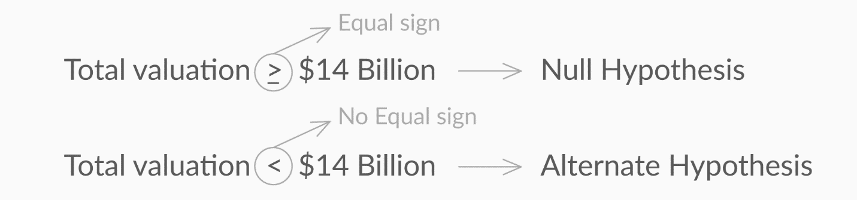

Figure 1 - Hypotheses for Situation 1

**Situation 2:**  Flipkart claimed that its total valuation in December 2016 was greater than $14 billion. Here, the claim contains > sign (i.e. the ‘more than’ sign), so**the null hypothesis is the complement of the original claim**. The hypothesis in this case can be formulated as:

The hypothesis in this case can be formulated as:

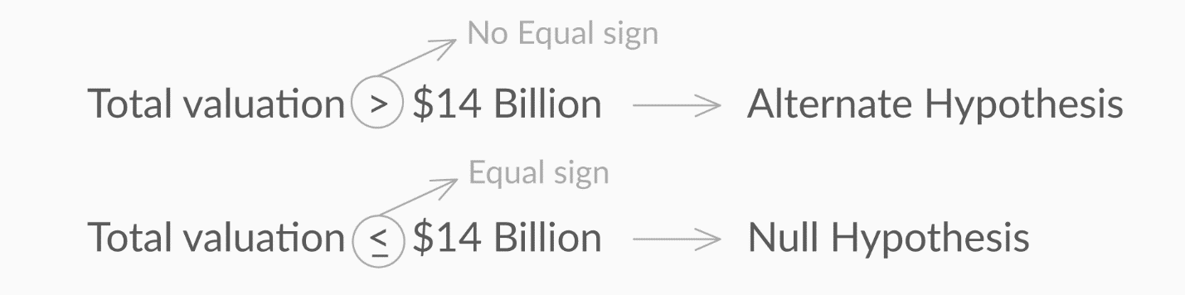

Figure 2 - Hypotheses for Situation 2

The formulation of the null and alternate hypotheses determines the type of the test and the position of the critical regions in the normal distribution.

You can tell the type of the test and the position of the critical region on the basis of the ‘**sign’ in the alternate hypothesis.**

       ≠ in H₁    →   Two-tailed test        →     Rejection region on **both sides** of distribution

       < in H₁    →   Lower-tailed test     →     Rejection region on **left side** of distribution

       > in H₁    →   Upper-tailed test     →     Rejection region on **right side** of distribution

**Critical Value Method**

Now, let’s learn how to find the critical values for the critical region in the distribution and make the final decision of rejecting or failing to reject the null hypothesis.

Before you proceed with finding the Zc and finally the critical values, let’s revise the steps performed in this method till now.

1. First, you define a new quantity called α, which is also known as the significance level for the test. It refers to the proportion of the sample mean lying in the critical region. For this test, α is taken as 0.05 (or 5%).
2. Then, you calculate the cumulative probability of UCV from the value of α, which is further used to find the z-critical value (Zc) for UCV.

After formulating the hypothesis, the steps you have to follow to **make a decision** using **the critical value method** are as follows:

1. Calculate the value of Zċ from the given value of α (significance level). Take it a 5% if not specified in the problem.
2. Calculate the critical values (UCV and LCV) from the value of Zċ.
3. Make the decision on the basis of the value of the sample mean x with respect to the critical values (UCV AND LCV).

Question:

A manufacturer claims that the average life of its product is 36 months. An auditor selects a sample of 49 units of the product, and calculates the average life to be 34.5 months. The population standard deviation is 4 months. Test the manufacturer’s claim at 3% significance level using the critical value method.

First, you need to **formulate the hypotheses** for this two-tailed test, which would be:

                                   H₀:μ = 36 months and H₁: μ ≠ 36 months

Now, you need to follow the three steps to **find the critical values and make a decision**.

Try out the three-step process by answering the following questions.

Question 2:

Government regulatory bodies have specified that the maximum permissible amount of lead in any food product is 2.5 parts per million or 2.5 ppm. Let’s say you are an analyst working at the food regulatory body of India FSSAI. Suppose you take 100 random samples of Sunshine from the market and have them tested for the amount of lead. The mean lead content turns out to be 2.6 ppm with a standard deviation of 0.6.

One thing you can notice here is that the standard deviation of the sample is given as 0.6, instead of the population’s standard deviation. In such a case, you can approximate the population’s standard deviation to the sample’s standard deviation, which is 0.6 in this case.

Answer the following questions in order to find out if a regulatory alarm should be raised against Sunshine or not, at 3% significance level.

1. Hypothesis — a claim or an assumption that you make about one or more population parameters
2. Types of hypothesis:
   * **Null hypothesis** (H₀) - Makes an assumption about the status quo  
                                          - Always contains the symbols ‘=’, ‘≤’ or ‘≥’
   * **Alternate hypothesis** (H₁) - Challenges and complements the null hypothesis

                                                                  - Always contains the symbols ‘≠’, ‘<’ or ‘>’

1. Types of tests:
   * **Two-tailed test**- The critical region lies on both sides of the distribution  
                                  - The alternate hypothesis contains the ≠ sign
   * **Lower-tailed test**- The critical region lies on the left side of the distribution  
                                     - The alternate hypothesis contains the < sign
   * **Upper-tailed test**- The critical region lies on the right side of the distribution

                                                 - The alternate hypothesis contains the > sign

1. Making a decision - Critical value method:
   * Calculate the value of Zc from the given value of α (significance level)
   * Calculate the critical values (UCV and LCV) from the value of Zc
   * Make the decision on the basis of the value of the sample mean ¯x with respect to the critical values (UCV AND LCV)

Cadbury states that the average weight of one of its chocolate products ‘Dairy Milk Silk’ is 60 g. As an analyst on the internal Quality Assurance team, you would like to test whether, at the 2% significance level, the average weight is 60 g or not. A sample of 100 chocolates is collected and the sample mean size is calculated to be 62.6 g. The standard deviation, as calculated from the sample, is 10.7 g.

Answer the following questions in order to draw a conclusion from the test.

